Project Document

Group 2

Jackson, Alonzo, Nolan, Emanuel

* It will be a general trivia website where quizzes will provide prizes
* This website will contain a database for trivia questions and potential prizes for participants to win.
* The website will be built in HTML/CSS/Javascript.
* There will be SQL databases integrated into the website for an array of prizes and questions.
* The website will be hosted on 00Webhosting.
* We will use MS Project to track the project and to produce gantt charts.
* We will use GitHub for our code repository and share code.

Jackson- assigned database and sql work 5/21

Alonzo- assigned HTML code and website front end work 5/21

Nolan- assigned project detailing and documentation 5/21

Emanuel- assigned social media management and some document work 5/28

Tasks for next Milestone #1

* Completion of website code - Alonzo, Jackson
* Updating database table formats as needed - Jackson
* Updating project documents - Nolan
* Managing social medias and miscellaneous document work - Emanuel

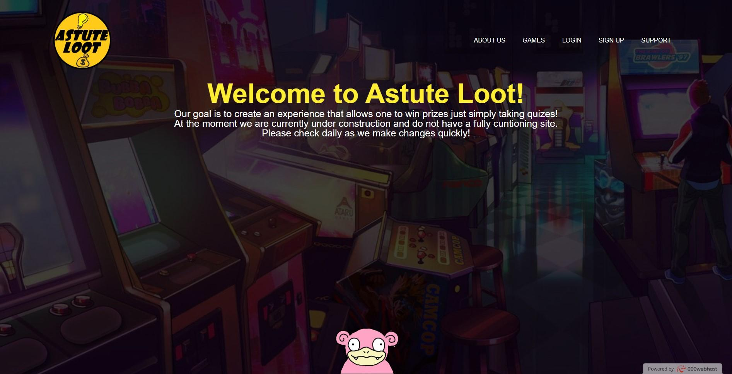

Emanuel- assigned gantt chart production and video production 5/26

Nolan- assigned graphic work and project manager role 5/21

Tasks for Milestone #2

Emanuel- Gant Chart is coming along nicely 6/11

Jackson - SQL database is almost finished 6/10

Alonzo - Website is up and running 6/6

Emanuel - Social medias are active and set up 6/11

Nolan - Respective documents updated 6/11

Alonzo - Website is nearly complete for launch. He is currently polishing. 6/24

Jackson - SQL database is finished and ready to go 6/24

Emaunel - Producing Gantt Chart for most recent milestone and week 6/24

Nolan - respective documents are updated 6/24

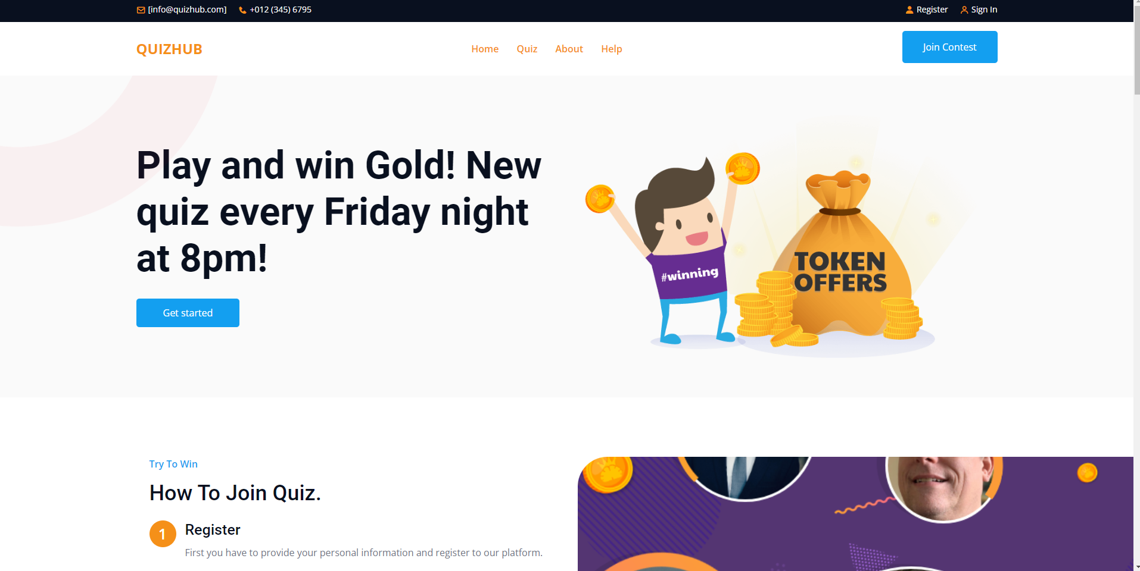

Alonzo -website is fully operational and a user can create an account 7/9

Jackson - potential prizes have been added into the database and a weekly quiz has been made available. 7/9

Emanuel - Social media have been updated and the new website has been showcased. 7/9

Nolan - Website user account has been created and weekly quiz has been tested. 7/9